Assignment Day 8

**1. Create a user named bob in Kali.**

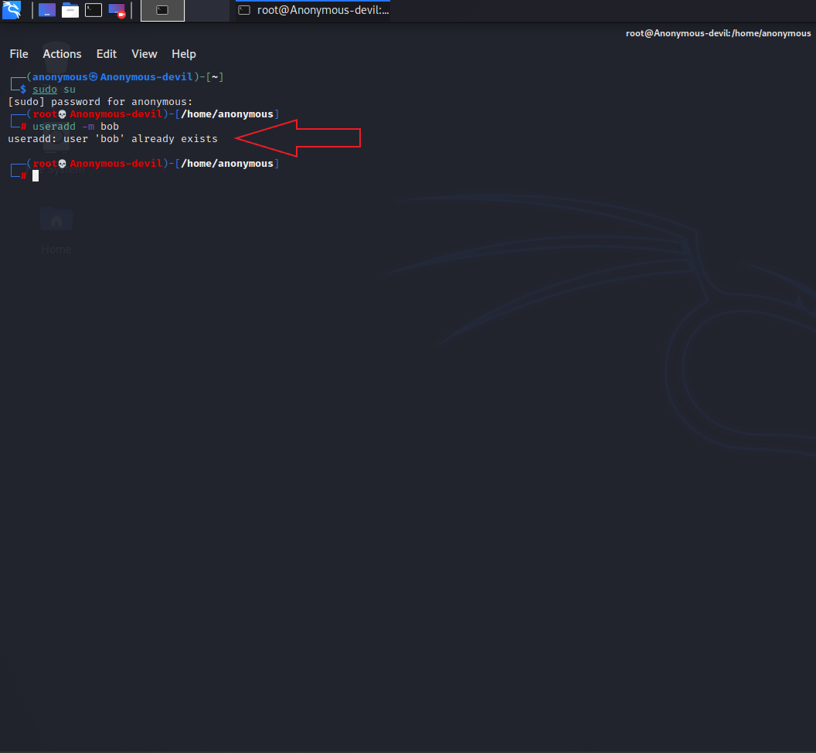

**2. Enable ssh on Kali**

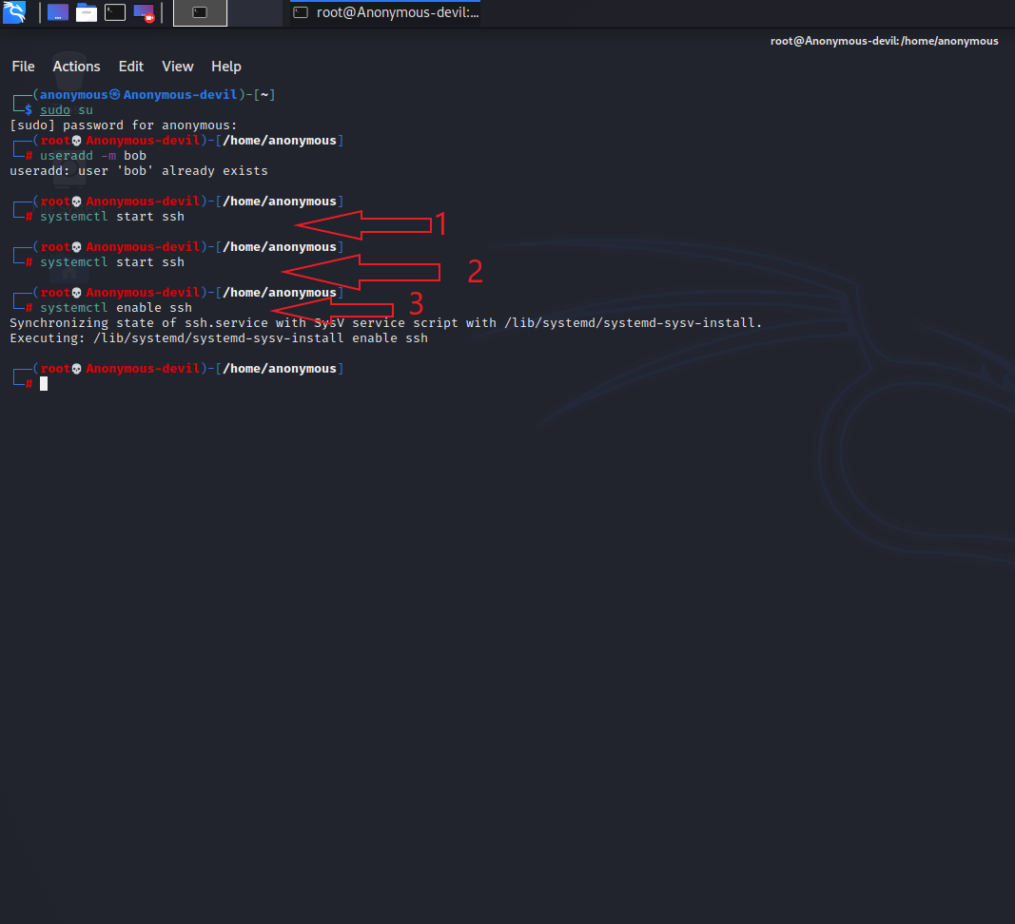

**3. Allow bob to login into kali from git bash without a password using keys.**

